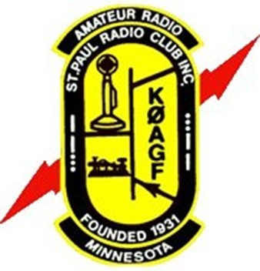 |  | Saint Paul Radio Club  www.stpaulradioclub.org  Est. 1931 | KØAGF  The Friendly Club  Home of the Friendly Net  28.310 MHz
Membership Data & Enrollment For the Year 2024-2025
Name: _________________________ ___ _________________________ Date ____/____/______
First M.I. Last
Address:_____________________ ________________ ______________ ____ _______
Street City County State Zip
Email:__________________________ ______ Phone: (____) ______________ (____) ______________ Circle one: Home/Cell/Work/Night Circle one: Home/Cell/Work/Night

Call:___________________________ License Class T G A E_ ARRL Member: ___YES___NO_ _LIFE__
(Amateur license is not required for membership ) Circle Circle

COMPLETING THIS FORM EACH YEAR HELPS KEEP YOUR INFORMATION CURRENT
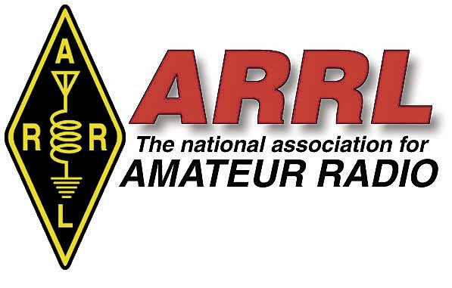

Would you be willing to volunteer to help The Saint Paul Radio Club? …………………. YES NO
Would you be willing to participate in Public Service Events? .................................. YES NO
Can the Saint Paul Radio Club help you with a Project? …………………………………………. YES NO
Saint Paul Radio Club — Regular and Special Member Dues Rates
- The Membership year runs from September 1 to August 31 of each year.
- A “Family Membership” includes all family members at the same address. Please use a separate membership form, filling out only the “Membership Data” for each family member.
- New members enrolling after April 1 will also receive next year’s membership.  

Please check one item:
____ Individual Membership: …………. $20.00 
____ Family Membership: ……………... $20.00
____ Full-time Student Membership $10.00 (18 years of age and older) Name of School________________________
____ Youth Membership (under 18 years of age) is a FREE membership

Membership Dues: From membership selected above $________________
$
#
/ /
Club Use Only
Optional Donation: Education & Amateur Radio Classes $________________ KØAGF Repeater Services (VHF/UHF) $________________
Undesignated / For General Fund $________________
Total Payment Enclosed: $________________
09-01-23
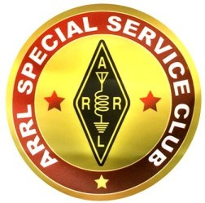 | Please fill out this form and bring to a club meeting or send to:  Saint Paul Radio Club  PO Box 9375  North Saint Paul, MN 55109-0375 |  |  | 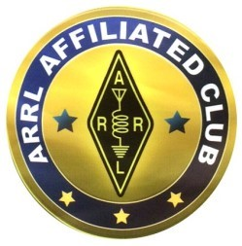
Please leave your comments on the reverse side.

